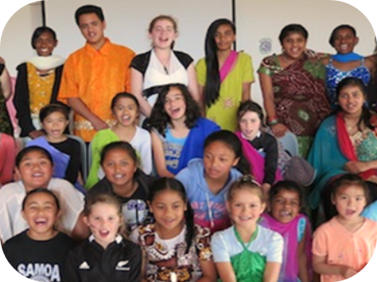



|  |  |  |  |  |  |  |  |  |  |  |  |  |  |  |  |  |  |  |
| --- | --- | --- | --- | --- | --- | --- | --- | --- | --- | --- | --- | --- | --- | --- | --- | --- | --- | --- |
|  |  |  |  |  |  |  |  |  |  |  |  |  |  |  |  |  |  |  |

**Randwick School Curriculum Overview**

The Randwick School curriculum covers both planning and practice. It provides an overview of “how we do things here”. It has been co-constructed through consultation with staff, students, parents/ whanau, our school whanau group and the local community and marae. It includes an overview of our curriculum concepts as well as Literacy and Mathematics Implementation Plans, Assessment and Reporting Guidelines, Evaluative Inquiry Process, Appraisal and our Maori and Pasifika Achievement Plans.

**Principles:**

1. **The Randwick School curriculum is driven by learner’s needs**. Planning begins with clarifying where students are at (using a range of assessment tools), where they need to be and how we are going to get them there. Assessment is for learning and is a process involving teachers, students and whanau.

2. **The Randwick School curriculum is driven by high expectations**. All of our learners have the potential to succeed given the right time and support. This requires planning teaching and learning experiences that challenge and motivate students to be *great kids who love learning*.

3. **The Randwick School curriculum is consistent with the New Zealand Curriculum.** Our curriculum is derived from the New Zealand curriculum but personalised to meet the needs of our learners. It is based on six core concepts that cover the New Zealand Curriculum learning areas. The Randwick School curriculum stems from our school vision, values and motto. These link to the New Zealand Curriculum principles, values and key competencies.

4. **The Randwick School curriculum reflects the cultural diversity of the school**. Our curriculum aims to raise Maori achievement and provide opportunities to celebrate the language, culture and identity of all of our Maori learners.

5. **The Randwick School curriculum is visible to learners.** The school vision and values will be visible to all learners. Our aim is for students to know where they are at in their learning, where they need to be and how they are going to get there. Learning progressions will be made available to children and they will be involved in goal setting and setting next steps.

6. **The Randwick School curriculum seeks high level student engagement.** Learning experiences will be linked to student need and interest and will encourage the learner to “take charge” of their learning through an inquiry approach. Students will be involved in decision making and student voice will be evident. 21st century learning tools and strategies will be integrated appropriately.

7. **The Randwick School curriculum is driven by key quality teaching principles**. These are based on what we deem to be effective practice to improve student achievement and engagement.

8. **The Randwick School curriculum has a clear planning structure and cycle.** Literacy and Maths implementation plans, long term plans and assessment and reporting guidelines make clear the processes that are followed at our school.

9. **The Randwick School curriculum requires ongoing Professional Learning and Teacher Inquiry.** Staff will regularly reflect on practice and seek professional learning opportunities to improve the quality of teaching and raise student achievement.

10. **The Randwick School curriculum review.** Ongoing review allows analysis of the curriculum as it impacts on teaching and learning and informs future direction and development.

|  |  |  |  |  |  |  |  |  |  |  |  |  |  |  |  |  |  |  |
| --- | --- | --- | --- | --- | --- | --- | --- | --- | --- | --- | --- | --- | --- | --- | --- | --- | --- | --- |
|  |  |  |  |  |  |  |  |  |  |  |  |  |  |  |  |  |  | logoA |

**Randwick School Quality Teaching Principles**

As a staff Randwick School have developed a core set of principles and strategies that underpin effective teaching. We believe that if these principles and strategies are implemented our children will benefit from quality teaching programmes and will be more likely to succeed and aspire to reach our school vision. We seek to develop student agency with our children so that they take responsibility for their learning, follow their passions and interests and are active in their learning.

* Relationships – whanaungatanga
* Knowing the learner – identity
* Providing a thinking / challenging / creative environment where students are active and questioning learners
* Teaching as inquiry
* Programmes that are relevant and personalised to students, make connections to the world including problem solving, innovation and opportunities for collaboration based on their interests and strengths
* Engagement and motivation
* eLearning opportunities
* High expectations / accelerated progress for all students
* Opportunities for children to develop the Randwick values
* Programmes are designed to meet student’s needs and are visible in the classroom
* Provide opportunities to involve students in making decisions about their learning
* Ako - reciprocal teaching and learning
* Assessment for learning
* Effective feed forward and feedback
* Teacher knowledge of the curriculum

|  |  |  |  |  |  |  |  |  |  |  |  |  |  |  |  |  |  |  |
| --- | --- | --- | --- | --- | --- | --- | --- | --- | --- | --- | --- | --- | --- | --- | --- | --- | --- | --- |
|  |  |  |  |  |  |  |  |  |  |  |  |  |  |  |  |  |  | logoA |

**School Vision:**

To empower great kids who love learning.

**School Motto:**

Think BIG

Think Different

**School Values**

**Confidence – standing up for what is right and**

**believing in yourself.**

**Relationships – valuing and supporting others, working positively together and caring and respecting each other.**

**Love of learning – wanting to learn in and out of school, ask questions, solve problems, follow passions and think in different ways.**

**Can do attitude – being the best that you can be, persevering and overcoming obstacles.**

**Identity – knowing who you are, where you’re from, your unique gifts and what drives you.**

**Communication – listening actively, speaking confidently, sharing ideas including using a range of tools and technologies.**

**Responsibility – doing the right thing, making positive choices, respecting others and property, making a difference for others and knowing your place in the world.**



**Maori Vision:**

To nurture the mana of the child.

|  |  |  |  |  |  |  |  |  |  |  |  |  |  |  |  |  |  |  |
| --- | --- | --- | --- | --- | --- | --- | --- | --- | --- | --- | --- | --- | --- | --- | --- | --- | --- | --- |
|  |  |  |  |  |  |  |  |  |  |  |  |  |  |  |  |  |  | logoA |

**English**

Literacy in English gives students access to the understanding, knowledge and skills they need to participate fully in the social, cultural, political and economic life of New Zealand and the wider world.

The focus is on the use and enjoyment of the English language and literature, communicated orally, visually, or in writing for a range of purposes and audiences, and in a variety of ways. Children read, respond and think critically about a range of texts and make connections between these and what they already know.

Effective Literacy learners grow a range of thinking strategies, skills, knowledge and tools to express and communicate their ideas clearly. They demonstrate digital literacy by communicating via a range of technology tools.

The goal is for children to develop multi literacies across all curriculum areas by demonstrating their understanding in a range of curriculum areas.

**Mathematics and Statistics**

By studying mathematics and statistics, students develop the ability to problem solve, think creatively, critically, strategically and logically.

The focus is on the exploration of the use of patterns and relationships in quantities, space and time and data. Students learn to estimate with reasonableness, calculate with accuracy, problem solve by drawing on knowledge and a range of strategies, recognize when results are accurate or doubtful and question the validity of data.

Effective Mathematics learners draw on knowledge, make connections, find patterns and ask questions. They use a range of thinking skills and strategies to problem solve and estimate with a sound number sense.

The goal is for children to apply their understanding and knowledge to a range of cross domain problems including real life problems.

**RANDWICK SCHOOL CURRICULUM STATEMENTS**

**The New Zealand Curriculum Key Competencies and Values and our School Values are integrated across our school curriculum.**

|  |  |  |  |  |  |  |  |  |  |  |  |  |  |  |  |  |  |  |
| --- | --- | --- | --- | --- | --- | --- | --- | --- | --- | --- | --- | --- | --- | --- | --- | --- | --- | --- |
|  |  |  |  |  |  |  |  |  |  |  |  |  |  |  |  |  |  | logoA |

**The Arts**

Learning in, through, and about the arts stimulates creative action and response by engaging and connecting thinking, imagination, senses and feelings. As students express and interpret ideas within creative, aesthetic and technological frameworks, their confidence to take risks is increased.

The focus is on expressing and interpreting ideas and responding to the works of others, communicating through movement, image and sound, creating and performing and representing ideas using a variety of mediums and techniques.

Artists can communicate their experiences, emotions, ideas and understandings in creative and innovative ways through different art forms and technology tools.

The goal is for children to nurture their artistic talents, grow others and appreciate the importance of The Arts in their lives.

|  |  |  |  |  |  |  |  |  |  |  |  |  |  |  |  |  |  |  |
| --- | --- | --- | --- | --- | --- | --- | --- | --- | --- | --- | --- | --- | --- | --- | --- | --- | --- | --- |
|  |  |  |  |  |  |  |  |  |  |  |  |  |  |  |  |  |  |  |

|  |  |  |  |  |  |  |  |  |  |  |  |  |  |  |  |  |  |  |
| --- | --- | --- | --- | --- | --- | --- | --- | --- | --- | --- | --- | --- | --- | --- | --- | --- | --- | --- |
|  |  |  |  |  |  |  |  |  |  |  |  |  |  |  |  |  |  |  |

**Health and Physical Education**

Health and Physical Education encourages students to take responsibility for their own well-being and incorporates the four core concepts of hauora, attitudes and values, interrelationships and health promotion.

The focus is on knowing the meaning of personal, social and community well-being and engaging in activities that promote it.

Healthy people are motivated and take ownership of their own personal well-being through making positive choices about the food they eat, physical activity and keeping safe. They have a positive mindset and understand that positive relationships and community members provide support and stability in times of change and challenge.

The goal is for children to take responsibility for their own health and well-being and understand the concept of hauora.



|  |  |  |  |  |  |  |  |  |  |  |  |  |  |  |  |  |  |  |
| --- | --- | --- | --- | --- | --- | --- | --- | --- | --- | --- | --- | --- | --- | --- | --- | --- | --- | --- |
|  |  |  |  |  |  |  |  |  |  |  |  |  |  |  |  |  |  |  |

Science

Science is a way of investigating, understanding, and explaining our natural, physical world, and the wider universe.

The focus is on investigating, understanding, explaining scientific ideas, hypothesizing, generating and testing ideas; gathering evidence from observations and investigations, and communicating findings, ideas and understandings.

Scientists can make meaning of our world by recognizing problems and issues and investigating using a fair testing process. They know that living things are connected and depend on each other for survival and that our universe is made up of complex and inter-connected systems and objects.

The goal is for children to explore the scientific world, ask questions and investigate solutions through experimentation and research.

|  |  |  |  |  |  |  |  |  |  |  |  |  |  |  |  |  |  |  |
| --- | --- | --- | --- | --- | --- | --- | --- | --- | --- | --- | --- | --- | --- | --- | --- | --- | --- | --- |
|  |  |  |  |  |  |  |  |  |  |  |  |  |  |  |  |  |  |  |

Social Sciences

Through the social sciences, students develop the knowledge and skills to enable them to: better understand, participate in, and contribute to the local, national, and global communities in which they live and work; engage critically with societal issues; and evaluate the sustainability of alternative social, economic, and environmental practices.

The focus is on how communities and societies work, and how people participate as informed, critical and responsible citizens.

Effective Social Science learners know that: history has important lessons that can help solve current problems and issues, citizens can contribute to the development and well being of society, people are part of diverse cultures and local, national and global communities, and social inquiry allows individuals to become informed, form opinions and challenge ideas.

The goal is for children to develop an understanding of their own identity, an appreciation for diversity and to contribute in meaningful ways to society, including enterprise and innovation.





|  |  |  |  |  |  |  |  |  |  |  |  |  |  |  |  |  |  |  |
| --- | --- | --- | --- | --- | --- | --- | --- | --- | --- | --- | --- | --- | --- | --- | --- | --- | --- | --- |
|  |  |  |  |  |  |  |  |  |  |  |  |  |  |  |  |  |  |  |

|  |  |  |  |  |  |  |  |  |  |  |  |  |  |  |  |  |  |  |
| --- | --- | --- | --- | --- | --- | --- | --- | --- | --- | --- | --- | --- | --- | --- | --- | --- | --- | --- |
|  |  |  |  |  |  |  |  |  |  |  |  |  |  |  |  |  |  |  |



Learning Languages

By learning an additional language and its related culture(s), students come to appreciate that languages and cultures are systems that are organized and used in particular ways to achieve meaning.

Te Reo Maori and New Zealand Sign Language are official languages of New Zealand.

The focus is on applying knowledge of a language by using the correct structures and vocabulary to communicate at a level appropriate to their age and ability.

The goal is for all students to develop literacy in Te reo Maori at a level appropriate to their age and ability and for Year 7-8 students to develop literacy in a combination of other languages such as Japanese and French.

Technology

Through technological processes students learn practical skills as they design, create, innovate and refine ideas .

The focus is on the use of practical approaches to develop products, systems, services and environments to meet needs and explore opportunities.

Effective Technologists create products and environments to meet needs and investigate technology inquiries to create design solutions and opportunities. They can choose and use a range of technology tools to suit the purpose.

The goal is for children to investigate and develop ideas based on need and follow a range of processes to create effective products, systems, services and environments.

|  |  |  |  |  |  |  |  |  |  |  |  |  |  |  |  |  |  |  |
| --- | --- | --- | --- | --- | --- | --- | --- | --- | --- | --- | --- | --- | --- | --- | --- | --- | --- | --- |
| Science  Science is a way of investigating, understanding, and explaining our natural, physical world, and the wider universe.  The focus is on investigating, understanding, explaining scientific ideas, hypothesizing, generating and testing ideas; gathering evidence from observations and investigations, and communicating findings, ideas and understandings.  Scientists can make meaning of our world by recognizing problems and issues and investigating using a fair testing process. They know that living things are connected and depend on each other for survival and that our universe is made up of complex and inter-connected systems and objects.  The goal is for children to explore the scientific world, ask questions and investigate solutions through experimentation and research. |  |  |  |  |  |  |  |  |  |  |  |  |  |  |  |  |  | logoA |

**Matauranga Maori Curriculum**

Māori language is the foundation of Māori culture and identity. Learning in and through Māori language is an important way for Māori students to participate in te ao Māori, it also supports students to connect with their identity as Māori. This is a strong foundation for well-being and achievement. Māori language is a taonga (treasure) and the government is committed to protecting it under the Treaty of Waitangi. Education provides an ideal vehicle to revitalise and sustain Māori language. -Tataiako

|  |  |  |  |  |  |  |  |  |  |  |  |  |  |  |  |  |  |  |
| --- | --- | --- | --- | --- | --- | --- | --- | --- | --- | --- | --- | --- | --- | --- | --- | --- | --- | --- |
|  |  |  |  |  |  |  |  |  |  |  |  |  |  |  |  |  |  |  |

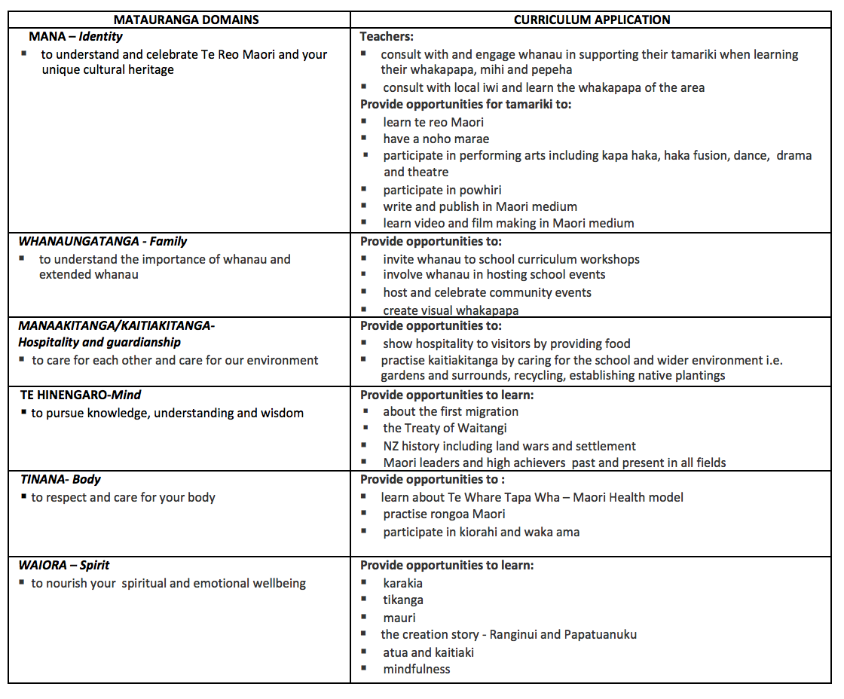

|  |  |  |  |  |  |  |  |  |  |  |  |  |  |  |  |  |  |  |
| --- | --- | --- | --- | --- | --- | --- | --- | --- | --- | --- | --- | --- | --- | --- | --- | --- | --- | --- |
| **Concept curriculum** |  |  |  |  |  |  |  |  |  |  |  |  |  |  |  |  |  | logoA |

Randwick School has developed our own curriculum after consulting with our school community – our children, parents, whanau, staff, Board of Trustees and wider community

Our curriculum has been designed by us to match the needs of our 21st Century learners. It puts children at the centre of learning and is designed to challenge them to think as well as follow their own areas of passion and interest. The Randwick School Curriculum is driven by high expectations, fostering a love of learning and drawing on the strengths and interests of our learners.  
We have selected six core concepts that will make up the basis of our school curriculum and will be delivered using an integrated inquiry learning approach. These concepts cover the core learning areas of Science, Social Sciences, Health and Physical Education and they integrate the learning areas of English, Mathematics, Technology, The Arts and Languages. It also incorporates the Principles, Values and Key Competencies of the New Zealand Curriculum as well as our own school values.

The six concepts are designed to provide a range of possibilities and promote challenge, depth of thinking, questioning and collaboration. Children are expected to analyse and make judgements and apply their learning to a range of situations. Children are encouraged to develop a sense of community by acting on their learning to make a difference for themselves or others.

Our six curriculum concepts are:

• **Relationships and Responsibilities** - this concept explores relationships and the impact of how we interact with others. This explores our responsibilities towards ourselves, others, the community and the environment.

• **Back to Front** – explores historical perspectives in order to understand the present and the future. Personal reaction and interpretation of events will be encouraged as well as imagining possible futures.

• **Enterprise and Innovation** – encourages children to be entrepreneurial, innovative and creative. It involves exploring the development of an idea into a product or service and exploring how the business world works.

• **Through the lives of others** – explores viewing and understanding the inter-relationships between the individual, others and society. It looks at different perspectives, respecting others and forming positive relationships.

• **Culture and Identity** – explores the concept of cultural diversity as well as personal, group and cultural identities. It explores relationships with others and respecting identity.

• **Change and Challenge –** explores the concept of change and the challenges presented. It includes hauora, personal growth and identity as well as exploring events, experiences and actions in the past, present and future. Challenges can be opportunities.

|  |  |  |  |  |  |  |  |  |  |  |  |  |  |  |  |  |  |  |
| --- | --- | --- | --- | --- | --- | --- | --- | --- | --- | --- | --- | --- | --- | --- | --- | --- | --- | --- |
| **Relationships and Responsibilities** |  |  |  |  |  |  |  |  |  |  |  |  |  |  |  |  |  |  |



This theme explores relationships and the impact of how we interact with others.

• This explores our responsibilities towards ourselves, others, community and the environment.

• This promotes an understanding that relationships exist between people and the environment, and that they both rely on each other (interdependence).

• You will explore your rights and responsibilities as you learn about your role in the school and wider community.

**Curriculum Connections:**

*Science* – Planet Earth and Beyond, Living World

*Health and Physical Education* – movement, concepts and motor skills, healthy communities and environment, relationships with others.

*Social Science* – Place and Environment.

**Big Idea Possibilities:**

• Conscience or convenience

• Constructing the future

• Changing responsibilities

• Leadership

• Jobs / career – how do we rely on people / jobs / gardening / community gardens / fishing industry / sustainability

• Community – relationship building with shopkeepers, utilising shops, library / impact on community – river, graffiti, community spirit



|  |  |  |  |  |  |  |  |  |  |  |  |  |  |  |  |  |  |  |
| --- | --- | --- | --- | --- | --- | --- | --- | --- | --- | --- | --- | --- | --- | --- | --- | --- | --- | --- |
|  |  |  |  |  |  |  |  |  |  |  |  |  |  |  |  |  |  |  |

**Back to Front**

This theme explores historical perspectives in order to understand the present and future. Personal reaction and interpretation of events will be encouraged as well as imagining possible futures.

• This explores the concept of our present being influenced by our past and impacting on our future.

• This explores understanding that events have cause and effect.

**Curriculum Connections:**

*Science* – living world – evolution.

*Health and Physical Education*– personal health and development.

*Social Science*– Continuity and change, Place and environment.

**Big Idea Possibilities:**

• Changing lifestyles

• Conflict

• Gender equity

• Extinction

• NZ history – introduction of humans to nature – rats, pests etc, establishing settlements

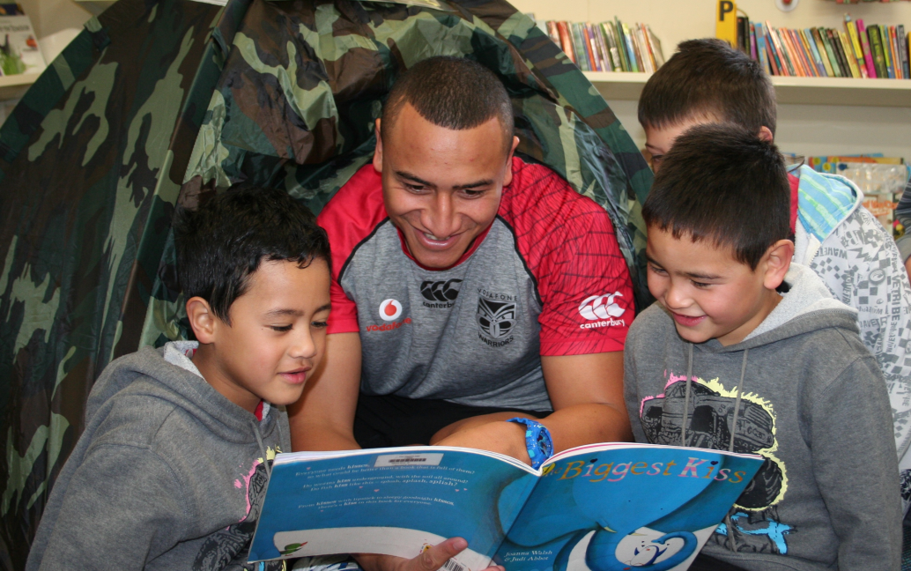

|  |  |  |  |  |  |  |  |  |  |  |  |  |  |  |  |  |  |  |
| --- | --- | --- | --- | --- | --- | --- | --- | --- | --- | --- | --- | --- | --- | --- | --- | --- | --- | --- |
|  |  |  |  |  |  |  |  |  |  |  |  |  |  |  |  |  |  | logoA |



This theme encourages you to be entrepreneurial, innovative and creative.

• This explores learning about how to generate new ideas, test them and evaluate them.

• This explores the development of an idea into a product or service and exploring how the business world works.

• Understanding how producers and consumers, exercise their rights and meet their responsibilities.

**Curriculum Connections:**

*Social Science*– Economic World

*Technology* – All Strands

**Big Idea Possibilities**

• Invention and design

• Creating a business – resources, profit, production

• Leading to a mini fair / market day

• Designing, making, selling, promoting, advertising etc.

**Enterprise and innovation**



|  |  |  |  |  |  |  |  |  |  |  |  |  |  |  |  |  |  |  |
| --- | --- | --- | --- | --- | --- | --- | --- | --- | --- | --- | --- | --- | --- | --- | --- | --- | --- | --- |
| **Culture and Identity** |  |  |  |  |  |  |  |  |  |  |  |  |  |  |  |  |  | logoA |

This theme explores the concept of cultural diversity, personal and cultural identities.

• This explores relationships with others and respecting identity.

• This explores society, communities and how they function. Also looking at the diverse cultures and identities within them.

**Curriculum Connections:**

*Health and Physical Education*– relationships with others, personal health and physical development

*Social Science*– identity, culture and organisation.

*Science* – material world, physical world

**Big Idea Possibilities:**

• Immigrants

• Refugees

• Rituals

• Human rights

• Pay

• Cultural expectations

• Invention and Design

• My face, my place

**Whanau group ideas:**

• What can we take to the future – explore the past – respect for the past, what can we learn the past, what is important to retain? What can we learn from each other – modern v past, urban v rural, different tribes – similarities / differences – what’s changed?

• Whakapapa – exploring our stories from the past and how different cultures share these differently, what’s our history, what’s our future? Pepeha, mihimihi – importance of oral language.

• What’s important to different cultures?

• Hands on – physical representations of culture, heritage and identity.

|  |  |  |  |  |  |  |  |  |  |  |  |  |  |  |  |  |  |  |
| --- | --- | --- | --- | --- | --- | --- | --- | --- | --- | --- | --- | --- | --- | --- | --- | --- | --- | --- |
|  |  |  |  |  |  |  |  |  |  |  |  |  |  |  |  |  |  | logoA |

**Through the lives of others**

This theme explores viewing and understanding the interrelationships between the individual, others and society.

* This explores the concept of looking at different perspectives, respecting others and forming positive relationships.
* This explores the concept of looking at different perspectives in relation to past, present and future.
* This explores viewing how events and actions may have changed our lives or the lives of others.

**Curriculum Connections:**

*Healthy and Physical Education*– relationships with others

*Social Science*– continuity and change, identity, culture, and organisation, place and environment

**Big Idea Possibilities:**

* Immigrants
* Refugees
* Life through the eyes of someone else – walk a mile in my shoes
* Human rights
* Gender equity
* Disabilities

|  |  |  |  |  |  |  |  |  |  |  |  |  |  |  |  |  |  |  |
| --- | --- | --- | --- | --- | --- | --- | --- | --- | --- | --- | --- | --- | --- | --- | --- | --- | --- | --- |
|  |  |  |  |  |  |  |  |  |  |  |  |  |  |  |  |  |  | logoA |

**Change and Challenge**

This theme explores the concept of change and the challenges presented. Challenges can be opportunities.

• This explores learning in relation to the 5 science strands.

• This explores hauora, personal growth and identity

• This explores events, experiences and actions in the past, present and future.

**Curriculum Connections:**

*Science* - nature of science - living world, material world, physical world, planet earth and beyond.

*Health and Physical Education*– personal health and development

*Social Sciences*– continuity and change

**Big Idea Possibilities:**

• Puberty (H)

• Revolution (SS)

• Migration (SS / S)

• Kitchen Chemistry (S)

• Changing lifestyles (SS)

• Survival (SS/S)

• Adaptation (SS/S)

**Whanau group ideas**:

Our living earth – Papatuanuku – how we can care for Mother Earth, responsibilities for the future – land, water etc. Importance of te whenua to Maori. How has change threatened / challenged the Earth, exploring past and present – why, how, positive and negative impacts.

• Social responsibility

• Matariki – physical world

• Challenge - stereotypes